SEN 1211 Agent-Based Modelling

# Introduction

# Conceptual model

# Formalization

**Variables of households**

Setting up the households

* Manually set a value for the maximum bin-capacity;
* Manually set a satisfaction value *bin satisfaction* for each agent between [0,1] for the timestep 1;

Bin-satisfaction

* Variable-range:
  + The number 0 is the lowest satisfaction level of a household-agent.
  + The number 1 is the highest satisfaction level of a household-agent;
* The satisfaction value will be influenced by the available bin-capacity at a specific time;
  + Available bin-capacity > amount of waste of household-agent $→$ bin satisfaction * increase factor
  + Available bin-capacity = amount of waste of household-agent $→$ satisfaction value of the household-agent * 1;
  + Available bin-capacity < amount of waste of household-agent $→$ satisfaction value of the household-agent * reduction factor;

Available bin-capacity

* The available bin-capacity at timestep 0 is the maximum bin-capacity;
* The bin-capacity will be influenced by the amount of waste that each agent will drop at a specific time;

Amount of waste dropping by an agent at a specific time

* If the amount of the collected waste of an individual agent ≥ capacity of the agents’ individual bin then the agent will drop his waste;
* If the amount of the collected waste of an individual agent < capacity of the agents’ individual bin then the agent will not drop his waste;

The amount of the collected waste of an individual agent

* The amount of the collected waste of an agent at timestep 0 is equal to 0.
* The amount of the collected waste of an agent each timestep is influenced by the [some behaviour]
  + A number of +0, +1 or +2 each timestep

Recycle-perception

* The recycle-perception will be influenced by the bin-satisfaction;
* The recycle-perception will be influenced by the education-level;

Education-level

* Manually set an education-level value *education-level* for each agent between [1, 5] for the timestep 0;
  + The number 1 is the lowest education-level of an agent;
  + The number 5 is the highest education-level of an agent;
* The education-level will be influence by ….

**Variables of the general bin**

Composition of the waste of the general bin

* The composition of waste of the general bin depends on the collected waste of each agent;
* The amount of PMD in the general bin is the sum of the amount of PMD of each individual agent, who dropped in this specific general bin.
* The amount of organic-waste in the general bin is the sum of the amount of organic-waste of each individual agent, who dropped in this specific general bin.
* The amount of non-PMD in the general bin is the sum of the amount of non-PMD of each individual agent, who dropped in this specific general bin.

Composition of the waste of each agent:

* The collected waste of each agent has a specific composition of waste;
  + PMD
  + Organic
  + Non-PMD
* The specific composition of waste of each agent depends on the recycle-perception and on the education-level.

Time of

**Variables of the regional-bin**

Amount of waste of the regional-bin

* The amount of PMD in the regional-bin is the sum of the amount of PMD of each general bin in the region.
* The amount of organic-waste in the regional-bin is the sum of the amount of organic waste of each general bin in the region.
* The amount of non-PMD in the regional-bin is the sum of the amount of non-PMD of each general bin in the region.

Amount of general bins in the region

**Variables of the waste companies**

The

**Notes 09-12-2021**

Locations of the general-bins

An agent walks to the closest one

Equal distribution

Distance from the general bin to the waste companie doesn’t matter, but it does matter if we include CO2.

3 different types of bins, or only 2 ? PMD and general waste

* Based on recycling perception/ education, quality of recycling;
* 100%

If the plastic bin is full, then it goes to the general waste

Collection of agents, an agentset

A function that create waste, later split it up to pmd, general waste and organic.

Splitting by 365, the whole year decreasing / increasing, a function, it can change by the initial value for amount of waste. 500 kg per person

Satisfaction level influence the perception level, influenced by the education level ?

Initial condition alfa for perception level, is affected by the education level.

Neighbours perception affect the perception level of the individual

If … > total capacity, bin is full

If bin is full > .. visa versa

If the pmd bin is full, then the agent will drop it in the general waste bin. This is the general bin. Will this affect the perception level?

Initial satisfaction level

Education level: [0, 5] - specification in the model

Perception level: [0, 1]

Satisfaction level: [0, 1]

Households – waste production

Waste production:

* PMD
* Generic waste

Initial conditions waste production per person each year (<https://www.milieucentraal.nl/minder-afval/afval-scheiden/afval-scheiden-cijfers-en-kilo-s/> ):

* Gft 140 kg per person
* PMD 24 kg per person
* Glas 27 kg per person
* Paper 59 kg per person
* Drink containers 4,6 kg per person

Pmd per week [kg] = pmd (24 kg) / 52 weeks

Non-pmd per week [kg] = ( glas (27 kg) + paper (59 kg) + drink containers (4,6 kg) + gft (140 kg) ) / 52 weeks = 90,6 or 230,6 / 52 weeks

Individuals own pmd and non-pmd – 1 person

* Pmd = 1 * pmd
* Non-pmd = 1 * non-pmd

Couples own pmd and non-pmd – 2 persons

* Pmd = 2 * pmd
* Non-pmd = 2 * non-pmd

Families own pmd and non-pmd – 4 persons

* Pmd = 4 * pmd
* Non-pmd = 4 * non-pmd

Waste production: waste = 40 – 0,04x – exp (-0,01x)*sin(0,3x) (function of assignment)

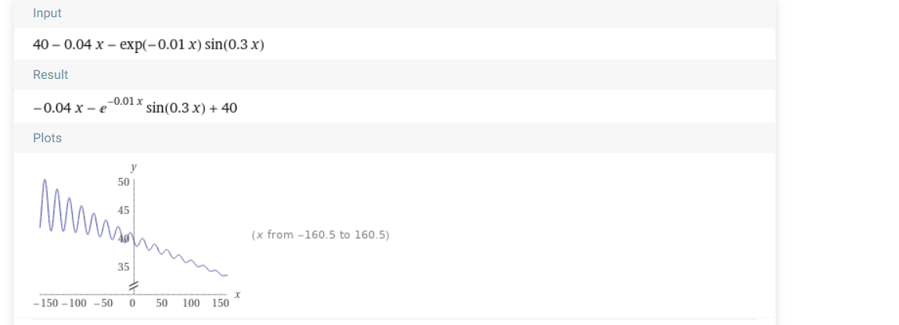

Or just a function that change the initial values each timestep? Then only 2 functions, the result will be multiplied for the number of persons of each household.

Given, initial conditions per person

* Pmd per week: 0,46 kg
  + 0,46 – (0,04/52) tick – exp ((-0,01/52) tick) * sin ((0,3/52) tick)
* Non-pmd per week: 1,74 kg
  + 1,7 – (0,04/52) tick – exp ((-0,01/52) tick) * sin ((0,3/52) tick)

PMD-waste production:

Individuals: 1 * pmd

Couples: 2 * pmd

Households: 4 * pmd

Non-pmd waste production:

Individuals: 1 * non-pmd

Couples: 2 * non-pmd

Households: 4 * non-pmd

# Implementation

# Model assumptions

# Model verification

# Experiments

# Analysis

# Conclusions